Lab Report – 5

Part A: RS Latch

Moida Praneeth Jain (2022101093, Group 4, Table 16)

**Objective**

* To design, assemble and test an RS Latch using NOR Gates.

**Electronic Components Required**

* Power Supply
* Breadboard
* LEDs
* Resistors
* Wires
* IC 4001 (Quad NOR Gate)

**The Reference Circuit**

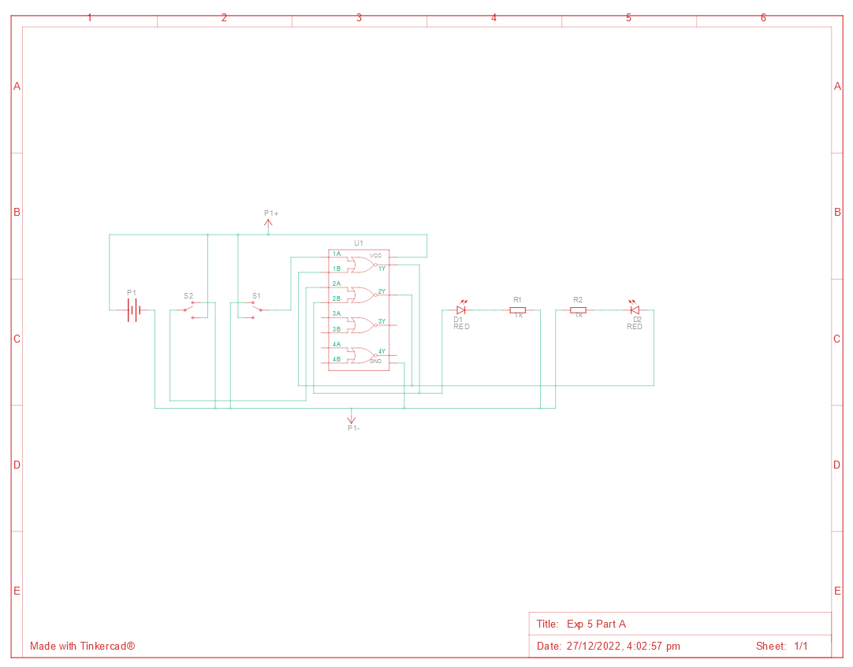

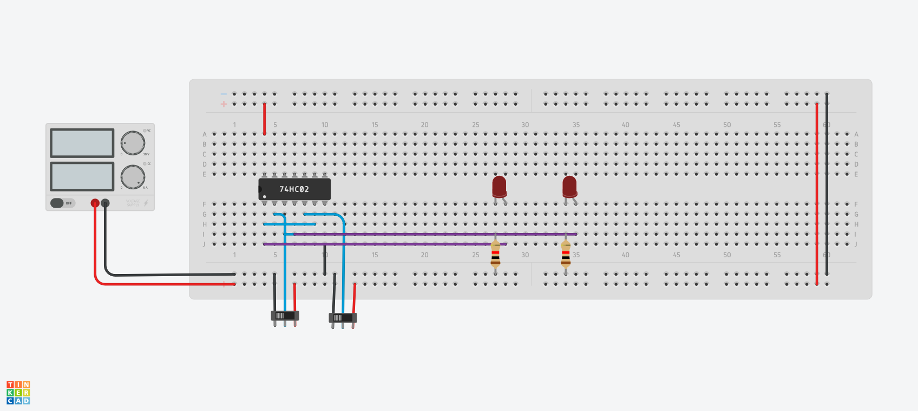**Procedure**

* Connect VCC and GND from the power supply to the breadboard.
* Connect the power and ground pins of the IC to VCC and GND using red and black wires respectively.
* NOR R and Q’ to get Q, then NOR S and Q to get Q’.
* Connect Q and Q’ to LEDs’ anode.
* Connect LEDs’ cathode to GND through a resistor.

**Observation**

|  |  |  |  |
| --- | --- | --- | --- |
| **S** | **R** | **Q** | **Q’** |
| 0 | 1 | 0 | 1 |
| 0 | 0 | 0 | 1 |
| 1 | 0 | 1 | 0 |
| 0 | 0 | 1 | 0 |
| 0 | 1 | 0 | 1 |
| 1 | 0 | 1 | 0 |
| 0 | 1 | 0 | 1 |
| 0 | 0 | 0 | 1 |
| 1 | 1 | 0 | 0 |
| 0 | 0 | 1 | 0 |
| 1 | 0 | 1 | 0 |
| 1 | 1 | 0 | 0 |
| 0 | 0 | 0 | 1 |
| 0 | 1 | 0 | 1 |
| 1 | 1 | 0 | 0 |
| 0 | 0 | 1 | 0 |

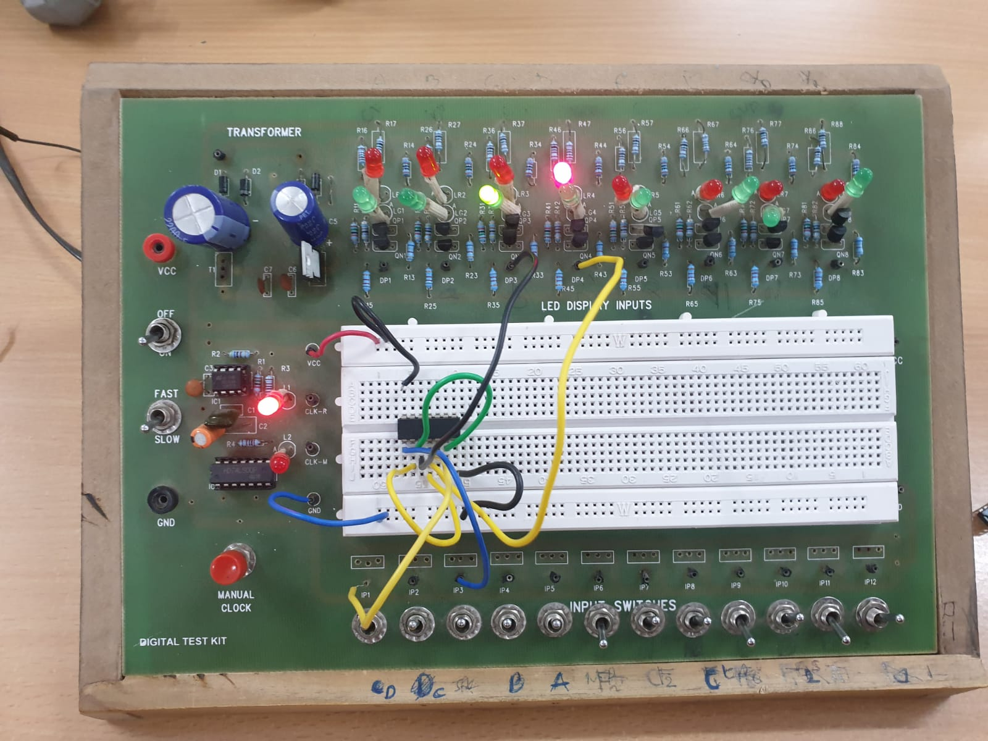

**Conclusion**

* The RS latch latches on to the last input, i.e., set when S is 1 and reset when R is 1.
* The RS latch is working as expected

TinkerCAD simulation link:

<https://www.tinkercad.com/things/634a1ECPCrp-exp-5-part-a/editel?sharecode=82gCZjBCWyynCRyM64HphT8Mz9cXHISC7ggcaKonh34>

Part B: JK Master-Slave Flip-Flop

Moida Praneeth Jain (2022101093, Group 4, Table 16)

**Objective**

* To design, assemble and test a JK Flip-Flop.

**Electronic Components Required**

* Power Supply
* Breadboard
* LEDs
* Resistors
* Wires
* IC 4001 (Quad 2-input NOR Gate)
* IC 4011 (Quad 2-input NAND Gate)
* IC 4012 (Double 4-input NAND Gate)

**The Reference Circuit**

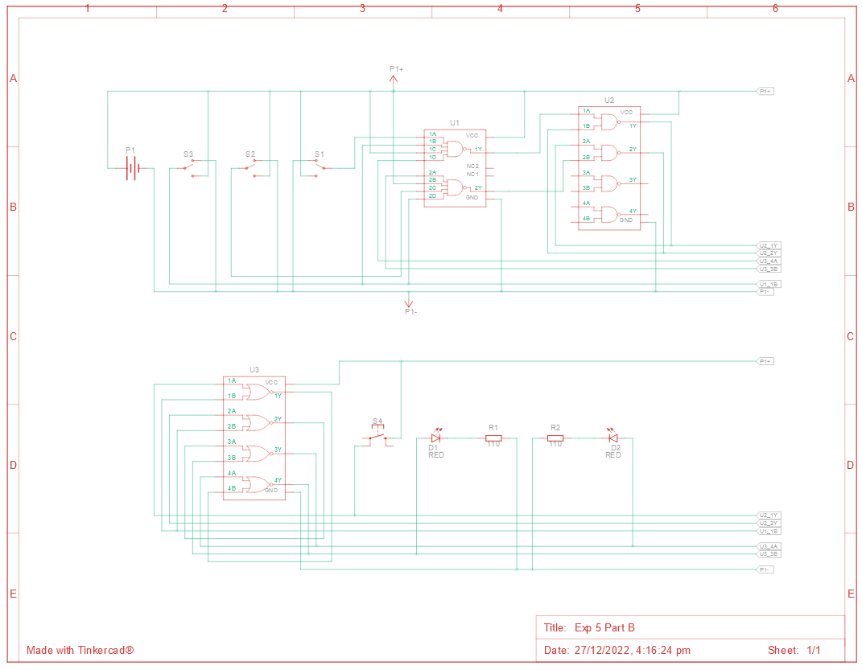

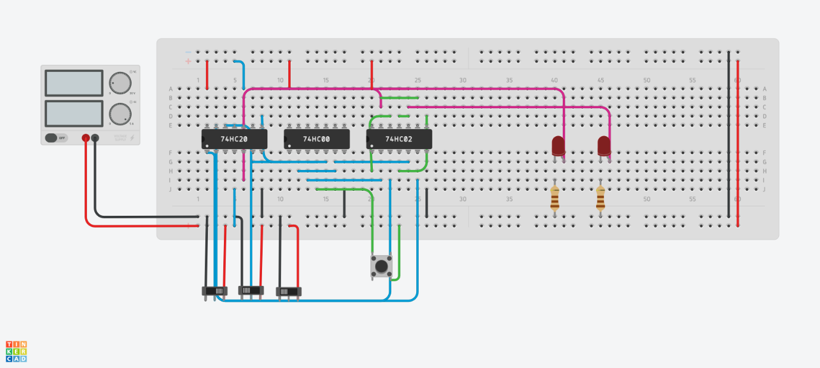

**Procedure**

* Connect VCC and GND from the power supply to the breadboard.
* Connect the power and ground pins of the ICs to VCC and GND using red and black wires respectively.
* Use the ICs to get the following outputs: (CK is clock)
  + Rm = K.Q.CK
  + Sm = J.Q’.CK
  + Ss = Qm.CK’
  + Rs = Qm’.CK’
* Connect Q and Q’ to LEDs’ anode.
* Connect LEDs’ cathode to GND through a resistor.

**Observation**

* The JK Flip-Flop is performing the following four functions:

|  |  |  |  |
| --- | --- | --- | --- |
| J | K | Action | Q(t+1) |
| 0 | 0 | Hold | Q |
| 0 | 1 | Reset | 0 |
| 1 | 0 | Set | 1 |
| 1 | 1 | Toggle | Q’ |

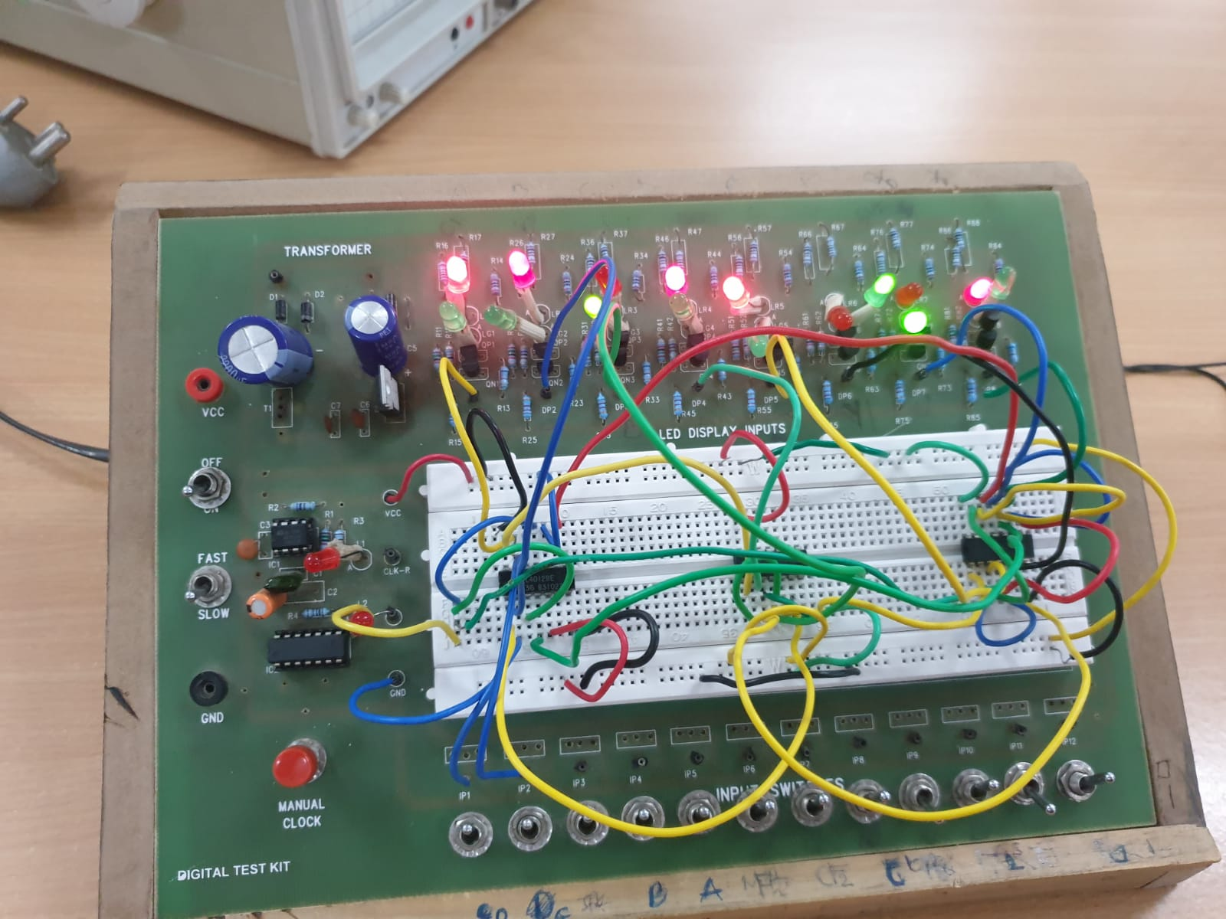

**Conclusion**

* The JK Flip-Flop is working as expected

TinkerCAD simulation link:

<https://www.tinkercad.com/things/iFsFettLh9p-exp-5-part-b/editel?sharecode=CLpJlwdxWZOuXIIqYV9F-EVO8g7yejX8qDnVGLTciZY>